Design document – Case study 2

Student: Marko Šestanović
PCN number: 558991

Table of Contents
1. Project overview 3
2. Requirements 4
3. Network topology 5
4. Choice justification 7

Project overview
The goal of this project is to create an environment which will be hosted on one of the cloud providers. The environment is supposed to be used for a short period during the peak hours for tickets sales of an event. The environment should function normally during those peak hours, but keeping the costs low should be in mind during development. The environment will consist of 2 web servers and a single database. Apart from that, the environment should have all the appropriate security, maintenance, and scalability functionalities.

Requirements
2.1 CI/CD pipeline
- Created a CI/CD pipeline for deploying and destroying the environment. The pipeline is deployed on Github and is using Github’s runner
- Important information such as “aws role arn” are configured into “secrets” section of the repository. The rest is under “variables”
- The pipeline automatically first verifies the code is written using correct syntax, then it runs terraform init, terraform plan with specific variables and lastly terraform apply.
2.2 Modular design
- The project’s architecture has been re-designed into modular setup
- Each component such as: compute, networking, storage... Has been separated in each module
- This design is better because it eliminates “Don’t repeat yourself” rule in terraform. Also it allows for easier version control since all you need to do is update a single module, apart from updating every section where that module would be called
2.3 Monitoring
- AWS Cloudwatch is connnected to all important components (ALB, Lambda, Aurora and RDS Proxy)
- Cloudwatch extracts important information such as requests rate on the ALB, successful/failed requests on the proxy, number of connections on the database, etc...)
- All the metrics are collected and sent to Grafana
- Grafana shows each resource’s important metrics with a dashboard
2.4 SOAR
- SOAR is implemented in the environment. There is a WAF which monitors amount of requests on the ALB. If WAF detects a high number of requests from one IP it sends an alert.
- The alert triggers SNS, which then sends an email to a security specialist.
- After sending the email, WAF automatically blocks the IP so in case this happens in a weird hour, the environment is safe.

Network topology
The following has been added to the network:
- Grafana dashboard
- WAF and SNS
- Automatic email sending system
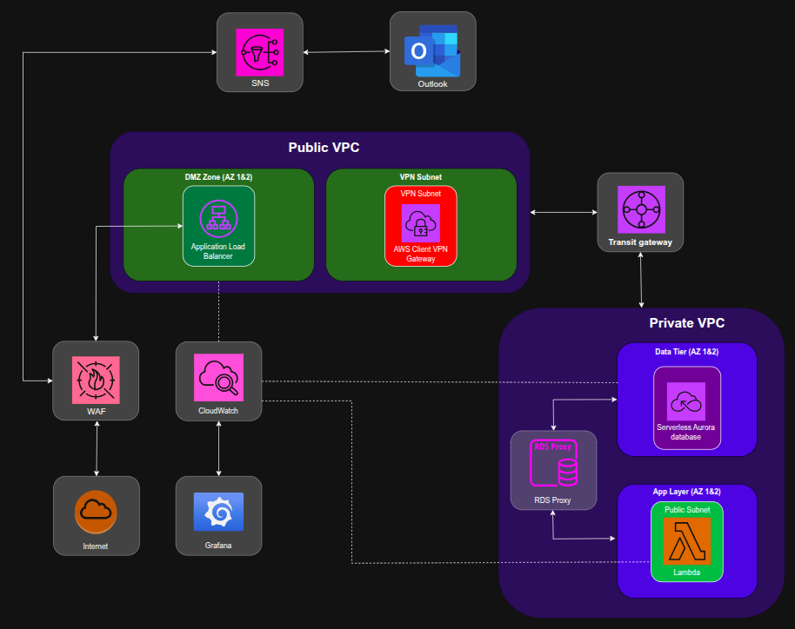The picture above shows the network diagram for the environment.

Choice justification
CI/CD pipeline – Since I used Github as my DevOps platform, it was logical to build a CI/CD pipeline on this platform. Since Github provides it’s own runner, I could simply use theirs.
Monitoring – Since I already had Cloudwatch connected to all my important resources, I didn’t need to worry about exporting logging data. Since Cloudwatch collects and stores metrics, all I needed to add was a dashboard to monitor the logs. I chose Grafana since it is the industry standard for dashboards
SOAR – For implementing SOAR, I had all the freedom as to what to implement in my environment. I chose to implement a DDoS prevention system. I simply deployed a Web Application Firewall, attached it to my ALB, setup a simple SNS resource and automated the process. If WAF notices a high number of requests from the same IP, it triggers SNS to send an email about the potential DDoS attack and automatically blocks the said IP. This fulfills the basic requirements of SOAR.

